5.1 Building Pipelines In Jenkins

This section will guide you to:
- Build multibranch pipelines in jenkins

This lab has two sub-sections, namely:
5.1.1 Configuring Pipeline plugin for Jenkins
5.1.2 Creating a Pipeline

Step 5.1.1: Configuring Pipeline plugin for Jenkins
- Go to Jenkins dashboard.
- Click on Manage Jenkins and select Manage Plugins.
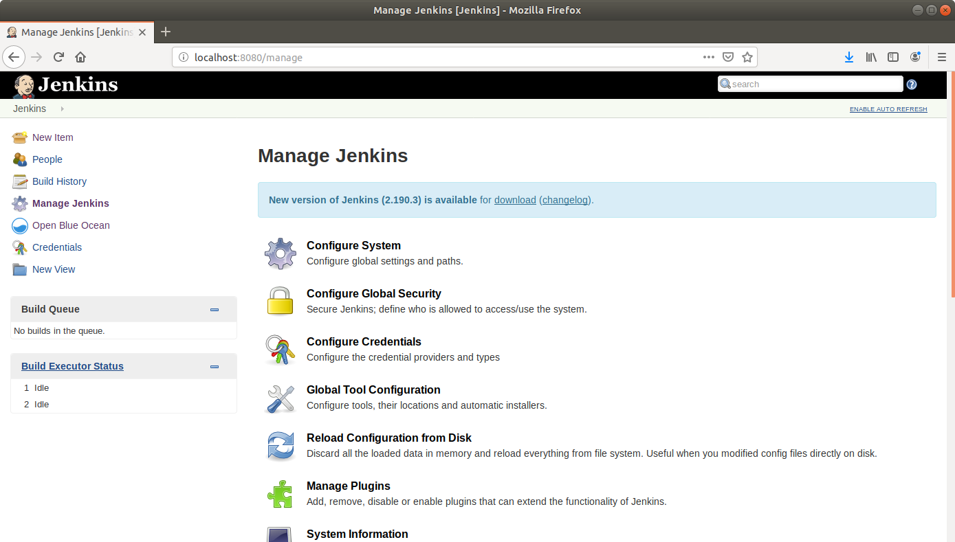
- Under the Available tab, select Pipeline.

- Click on Install without restart and the plugin will be installed.
- Click Save.

Step 5.1.2: Creating a Pipeline
- Go to Jenkins dashboard.
- Click on New Item.
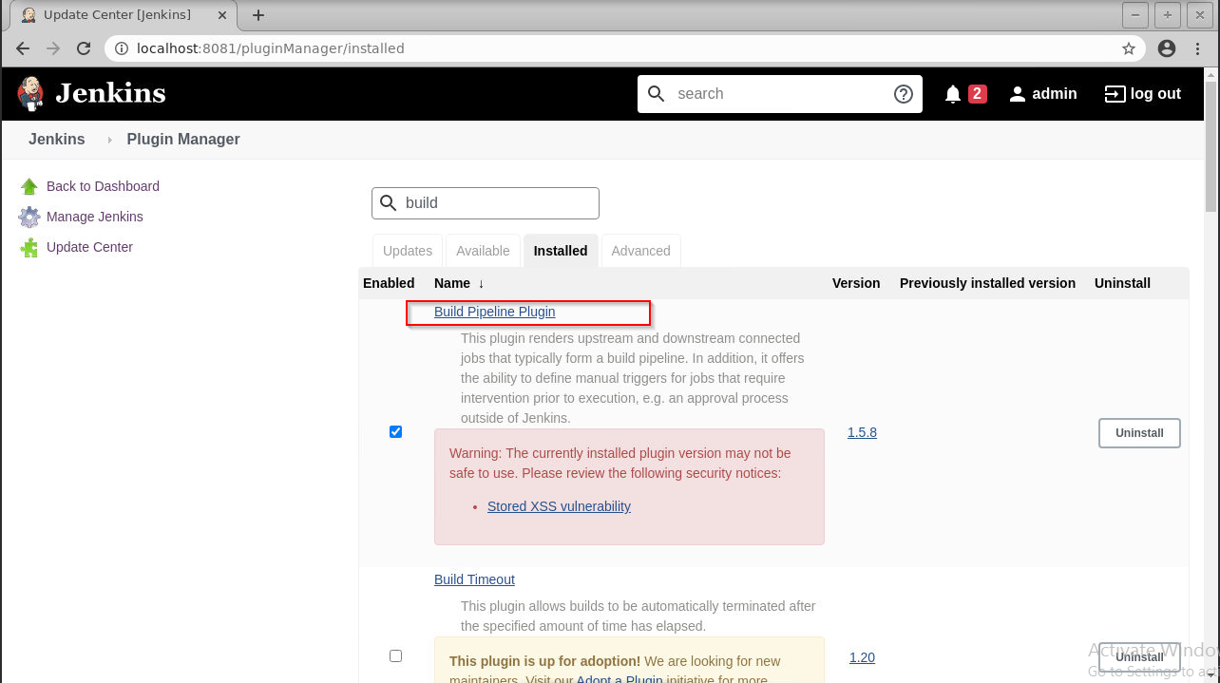
- Enter a name for your build job.
- Select Pipeline as the build job type.
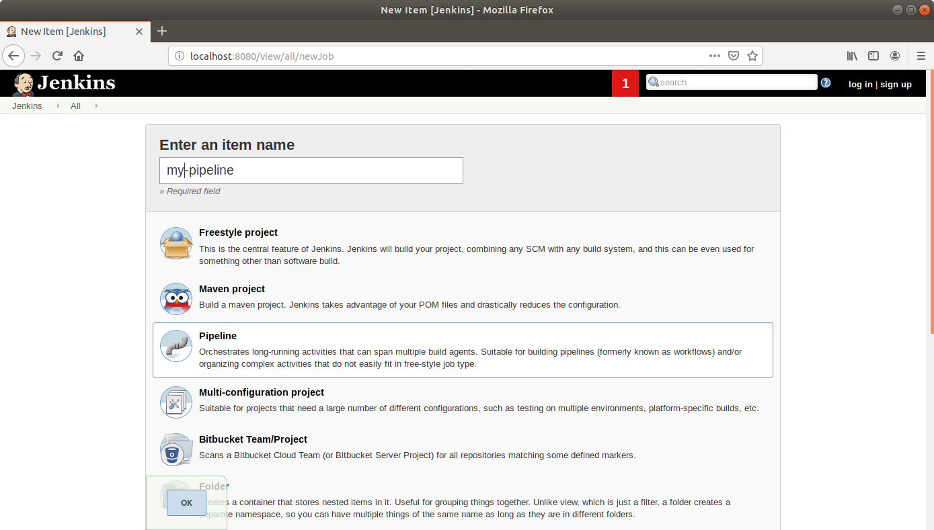

- Click OK.
- Scroll down to the Pipeline section and enter the script below:
pipeline {
agent any
stages {
stage('First Stage') {
steps {
echo 'Hello World'
}
}
stage('Second Stage') {
steps {
echo 'Hello Again'
echo 'A third time Hello'
}
}
}
}
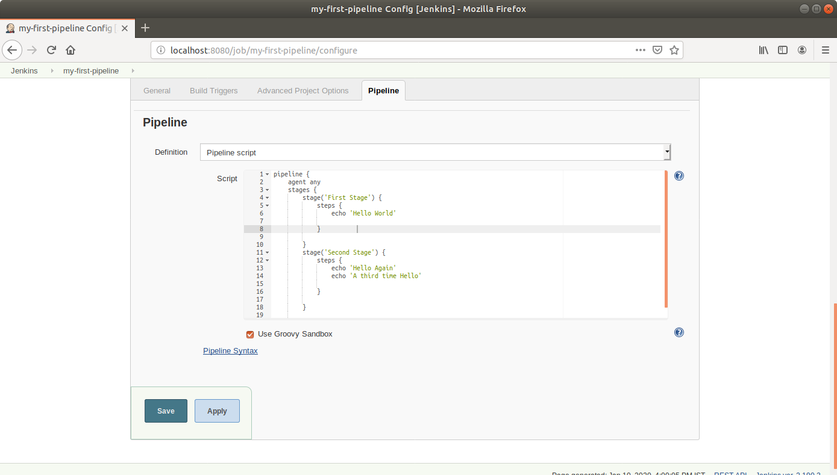
- Click Save.
- Click Build Now in the project window to make sure that the build works. Jenkins will now build your project.
- Click on the Build History to view the build results.
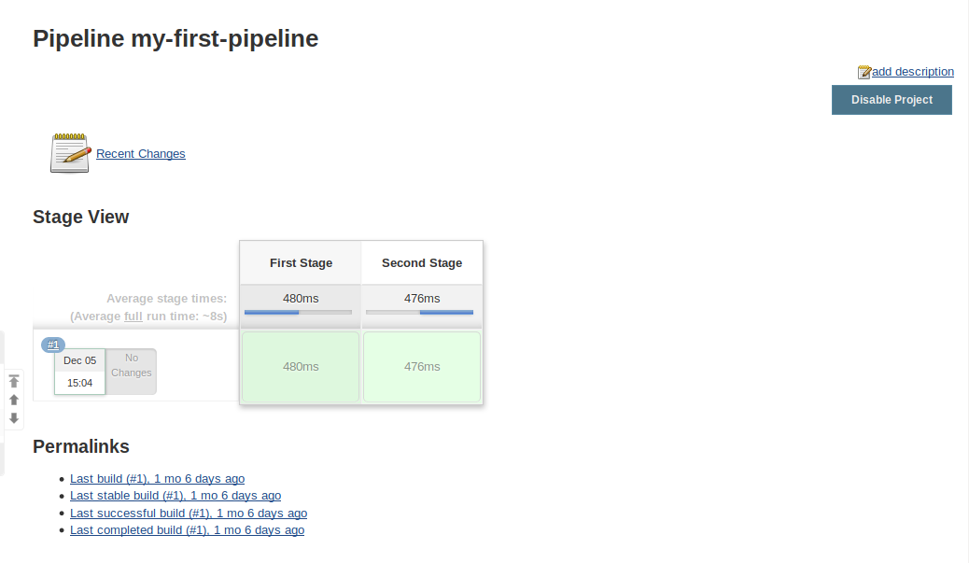
- Click on the Logs to view the build logs in each stage.
